**vv college of engineering,**

**tisaiyanvillai-627657**

**Safety Gadget for Child Safety Monitoring and**

**Notification**

**IBM NALAIYATHIRAN**

**Project Development –Delivery of Sprint 2**

**Creating Node –Red service and connect with IBM cloud and Web UI**

|  |  |
| --- | --- |
| **TITLE** | IOT based child safety gadget for child safety monitoring and notification |
| **DOMAIN NAME** | INTERNET OF THINGS |
| **TEAM ID** | PNT2022TMID50962 |
| **TEAM LEADERNAME** | sugi.l |
| **TEAM MEMBER NAME** | SANGEETHA.R  SARASWATHI VIDYA  SHOBISHA  SUJI |
| **MENTOR NAME** | BARADWAJ |

**Creating Node-Red service:**

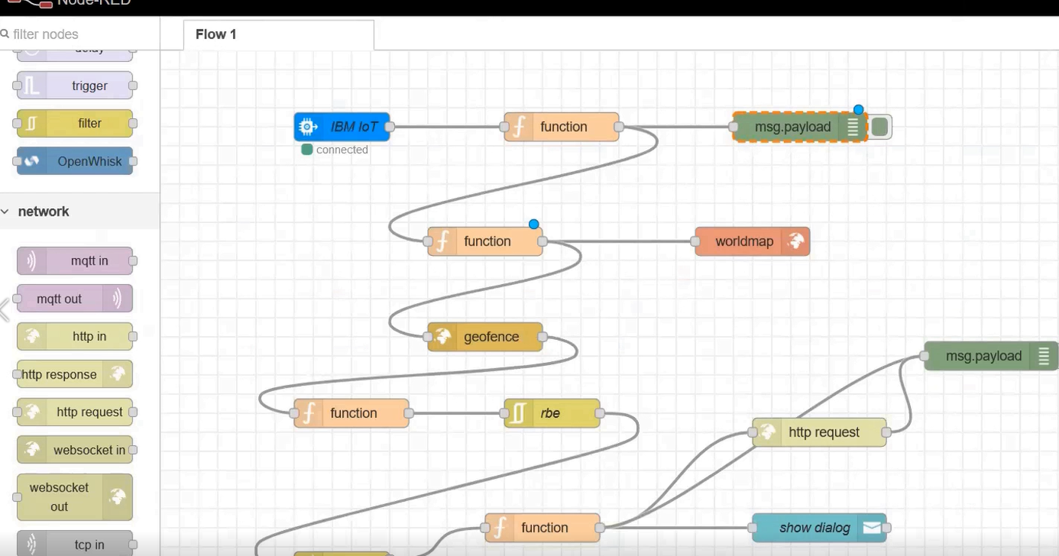

**Connecting with IBM Cloud:**

**Using IBM IOT node through API key**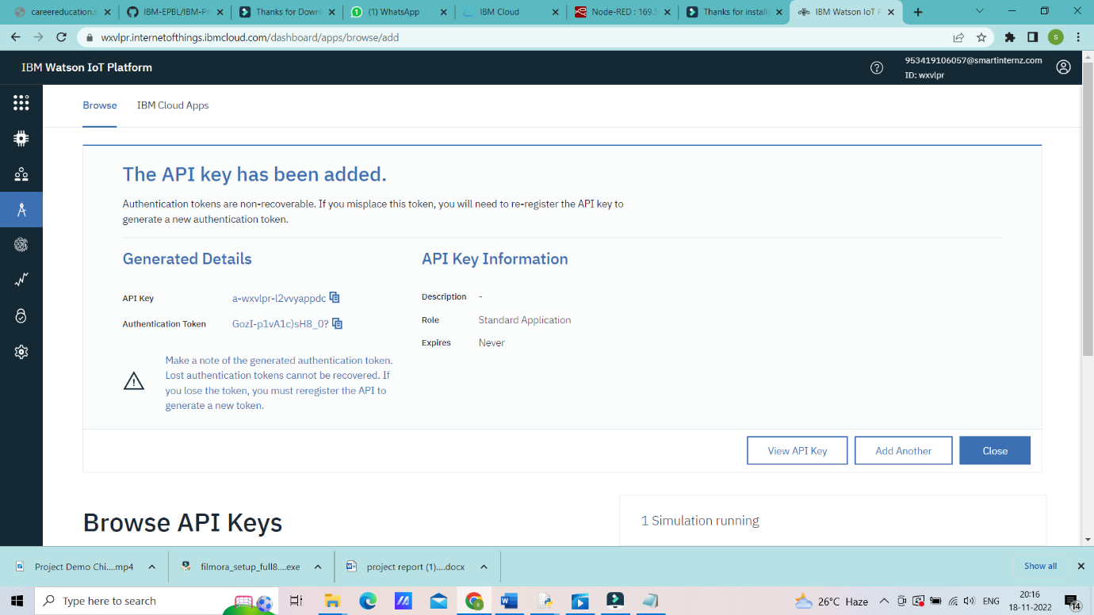

**Transfering values from Python Code:**

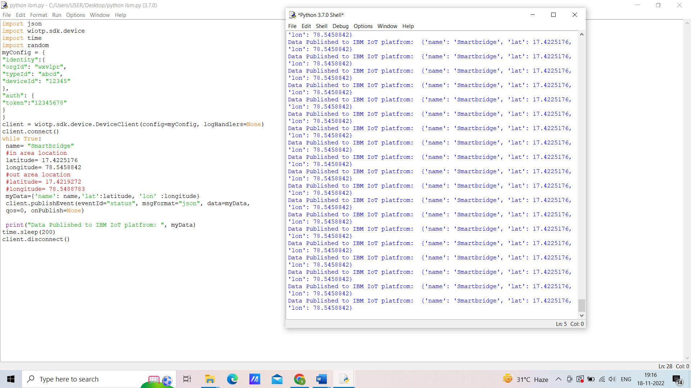

**Node-Red Dashboard:**

